

**EEEE1028 Power and Energy**

**Coursework 1**

**Investigating Kirchhoff’s Voltage Law and Resistor Combinations**

**Academic year: 2020 / 2021**

**Prepared by:**

**DEREK CHEEN XIN HEE**

**(20317350)**

**Circuit 1: Simple Resistor Circuit**

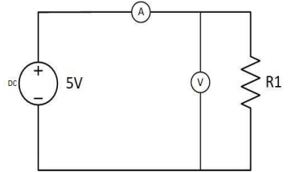

Figure 1 Circuit 1

**Question 1**

a) The effective resistance of the ammeter is very near to zero. Ideally, the resistance of an ammeter should be zero. Ammeter measures the amount of current flow in an electronic circuit, and it should always be connected in series with the circuit. According to Ohm’s law, if the resistance of an ammeter is high, the current flowing through the circuit will be low. As such, the resistance of the ammeter must be very low or near to zero so that it would not affect the amount of current flowing in the circuit.

b) The effective resistance of the voltmeter is very high. Ideally, the resistance of a voltmeter should be an infinite value. Voltmeter measures the potential difference between two points in an electronic circuit, and it should always be connected in parallel with the circuit. The resistance must be very high so that it only very little amount of current can pass through it.

**Question 2**

Value of resistance require for circuit 1 to have a supply current of 23mA:

By applying Ohm’s law,

Using PLECs simulation to check the calculated value:

When the resistance in Circuit 1, R1=217.39Ω, the current measured, I1=23mA, as shown in Figure 2.1 and Figure 2.2. The calculated value is the same as the simulated value.

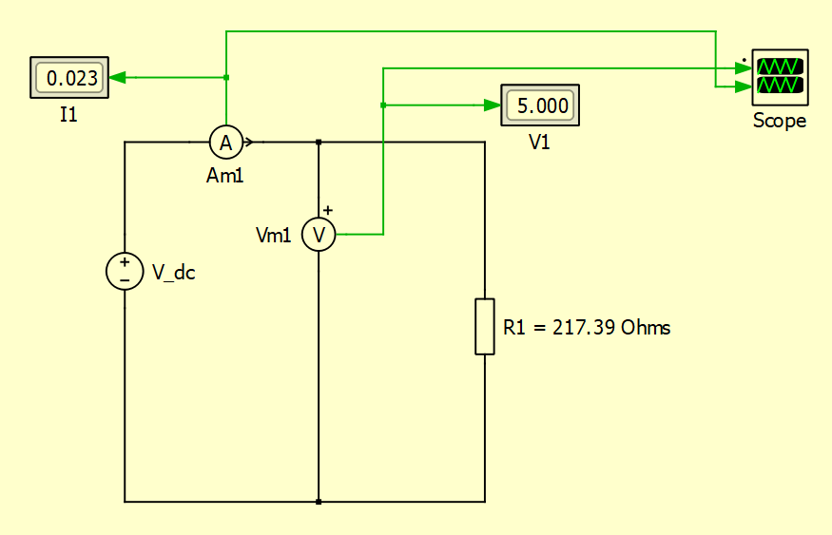

Figure 2.1 Circuit 1

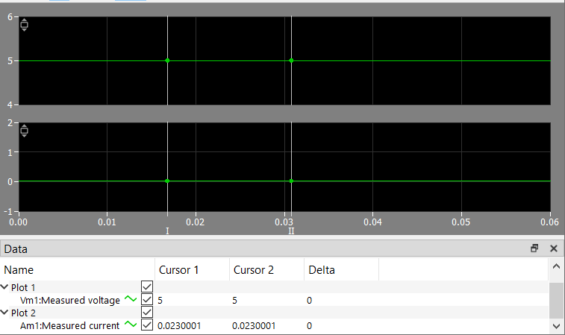

Figure 2.2 Reading of Vm1 and Am1

**Question 3**

From PLECs simulation, Vm1 measured is 5V and Im1 measured is 0.5A as shown in Figure 3.1 and Figure 3.2.

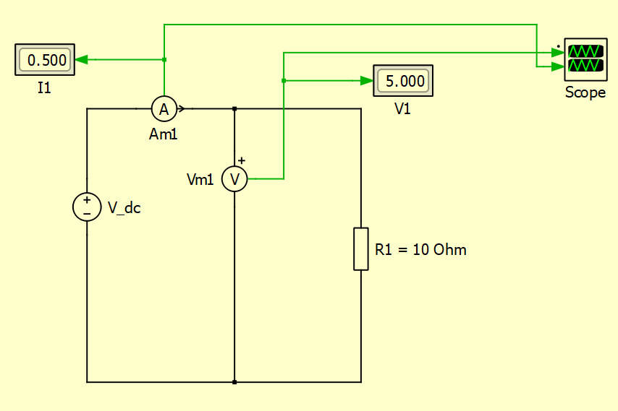

Figure 3.1 Circuit 1

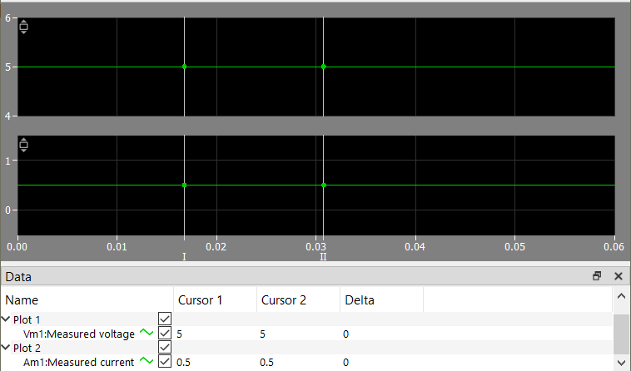

Figure 3.2 Readings of Vm1 and Am1

Checking whether the values obtained follow Ohm’s law:

Conclusion:

The value of current calculated using Ohm’s law is the same as the value of current obtained from the PLECs simulation. Thus, these **measurements follow Ohm’s law**.

**Question 4**

The minimum required power rating of the resistor is 0.115Watt.

**Circuit 2: Series-parallel Circuit**

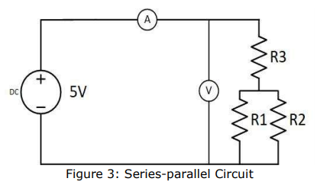

Figure 4 Circuit 2

**Question 5**

Total resistance of and :

Total resistance in the circuit:

Current passing through :

Using current divider rule to calculate and :

Calculating voltage across

and is the same because and are connected in parallel:

**Question 6**

The values of currents and voltages obtained from the simulation are shown in Figure 5.1, Figure 5.2, Figure 5.3, Table 1.1 and Table 1.2.

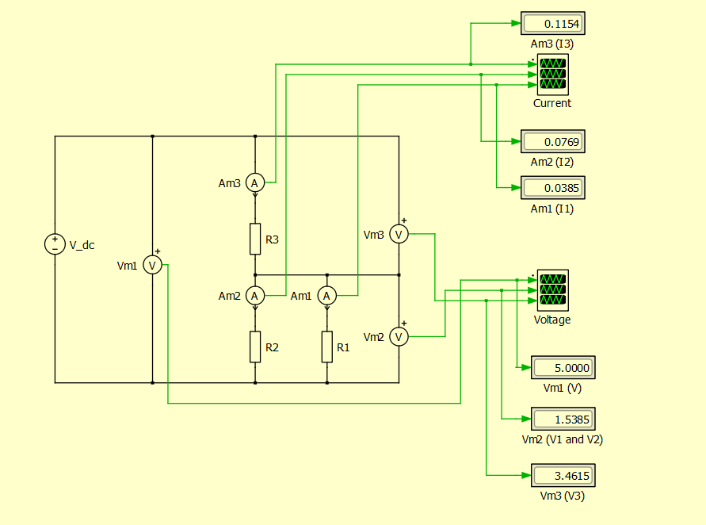

Figure 5.1 Circuit 2

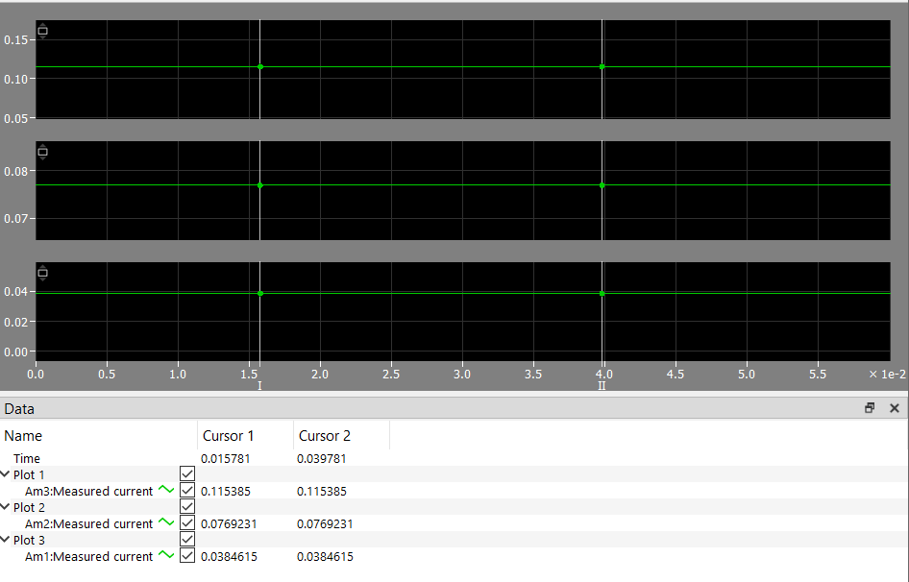

Figure 5.2 Currents, , and

measured by Vm1, Vm2 and Vm3 respectively

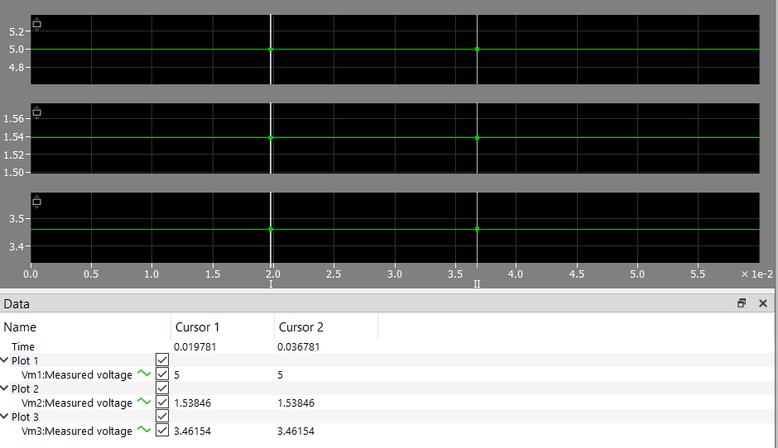

Figure 5.3 Voltages, , , and

measured by Vm1, Vm2 and Vm3

Data collected in table form:

|  |  |  |
| --- | --- | --- |
| **Ammeter** | **Current** | **Readings (A)** |
| Am1 |  | 0.0385 |
| Am2 |  | 0.0769 |
| Am3 |  | 0.1154 |

Table 1.1 Currents measured

|  |  |  |
| --- | --- | --- |
| **Voltmeter** | **Voltage** | **Readings (V)** |
| Vm1 |  | 5.0000 |
| Vm2 |  | 1.5385 |
| Am3 |  | 3.4615 |

Table 1.2 Voltages measured

Conclusion:

After comparing the results, it can be concluded that the results obtained from the simulation **matches** my calculated predictions.

A slight difference is that the values obtained from my calculations were rounded up to 3 decimal places whereas the values obtained from the simulation include more decimal places.

**Circuit 3: Series – Parallel – Series Circuit**

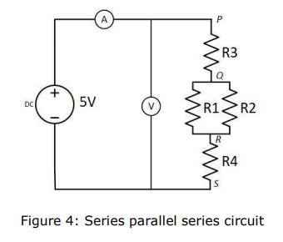

Figure 6 Circuit 3

**Question 7**

Total resistance of and is calculated above:

Value of R4 required to reduce the supply current to 50mA:

Supply current (), is equal to current in R3 and R4:

Using current divider rule to calculate and :

Calculating voltages across each resistor:

Voltage across and is the same since they are connected in parallel:

Voltage across :

Voltage across :

Measurements obtained from simulation are shown in Figure7.1, Figure7.2 and Figure7.3

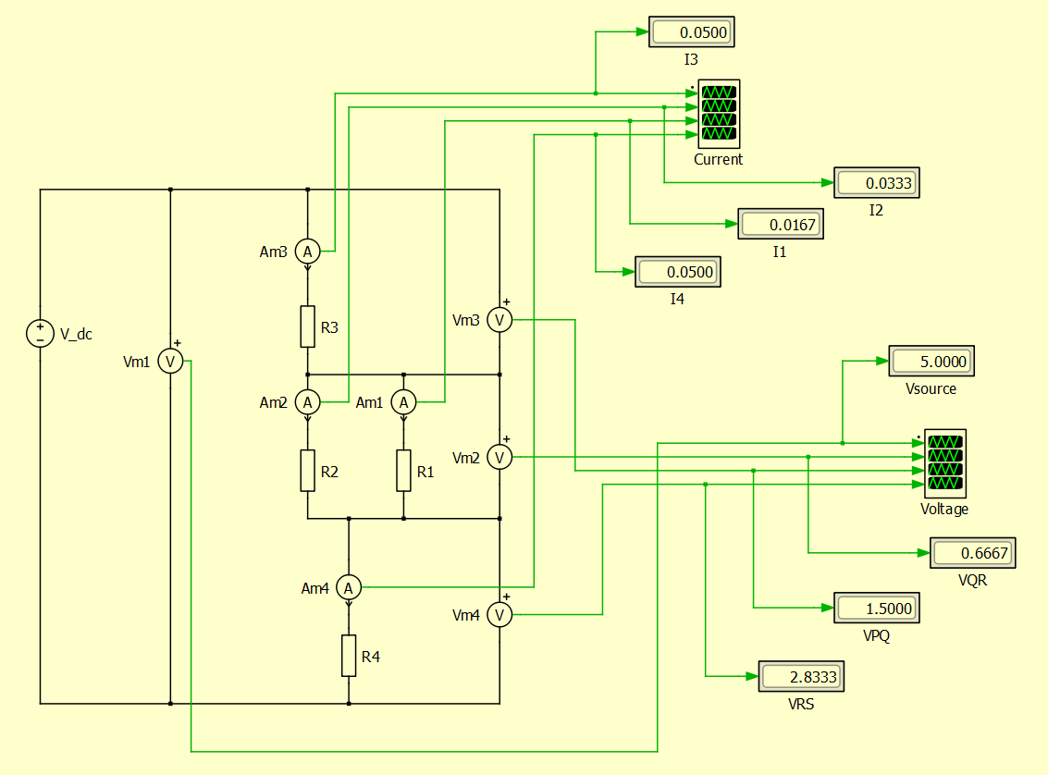

Figure7.1 Circuit 3

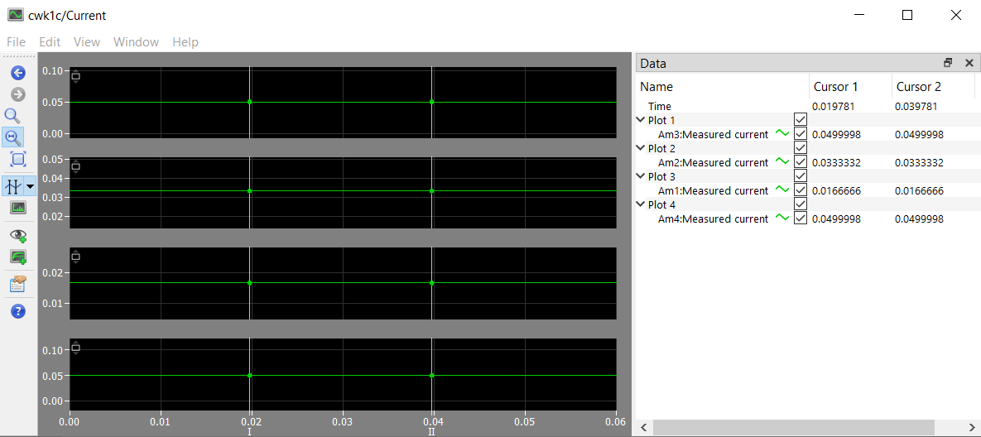

Figure7.2 Currents ,, and

measured by Am1, Am2, Am3 and Am4 respectively

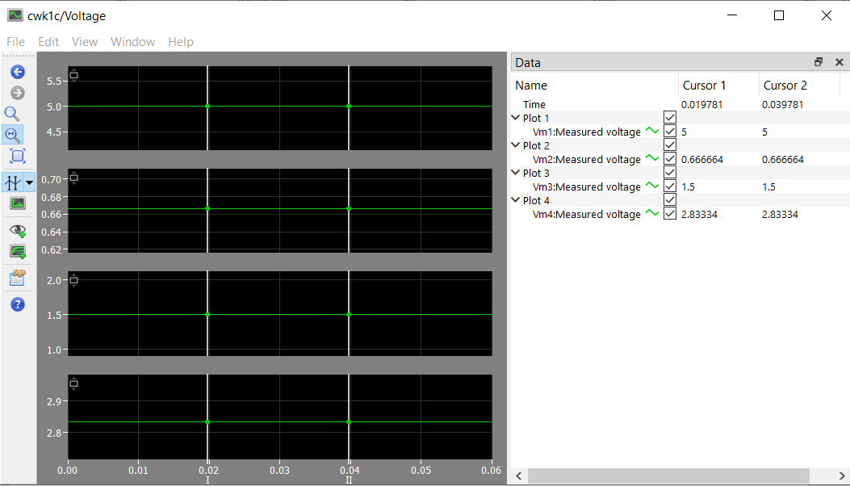

Figure7.3 Voltages ,, and

measured by Vm1, Vm2, Vm3 and Vm4 respectively

**Question 8**

By Kirchhoff’s Voltage Law:

The measurements obtained follows Kirchhoff’s Voltage Law.

By voltage divider rule:

**Question 9**

1) The potential of nodes P, Q, R and S.

since it is the ground point. To prove it mathematically:

2) Voltage between nodes P and R:

3) Potential difference between nodes S and Q:

The magnitude of potential difference between nodes S and Q is .

**Question 10**

**Circuit 5: Dual Supply Circuit**

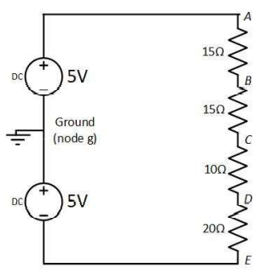

Figure 8 Circuit 5

**Question 11**

Calculating , , and :

By voltage divider rule:

Calculating :

Measurements obtained from the simulation is shown in Figure 9.

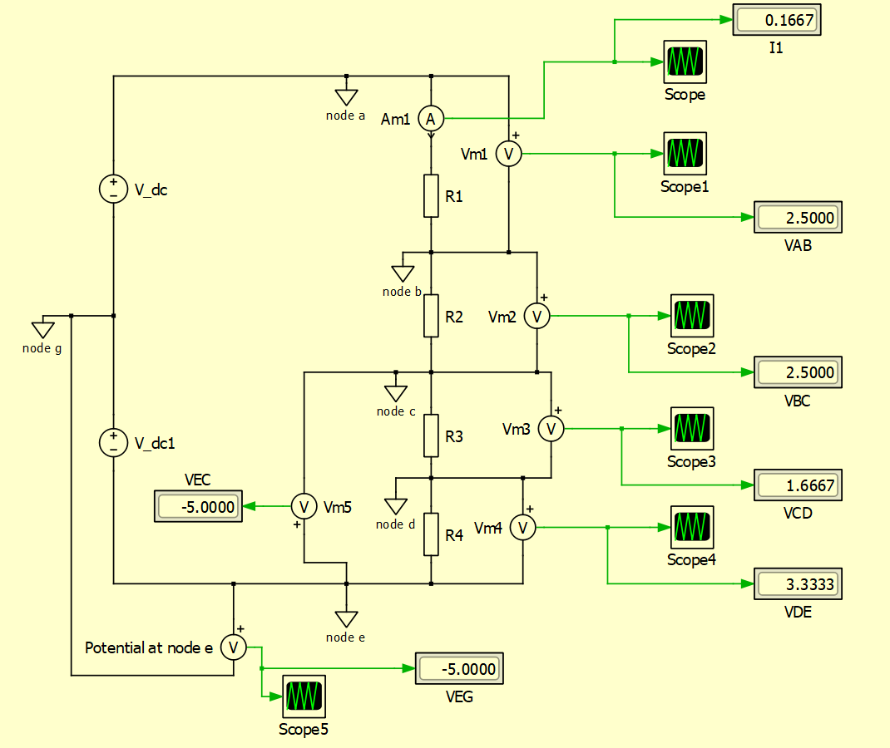

Figure 9 Potential difference across each node including

**Question 12**



Figure 10 Circuit 5

Potentials at node A, B, C, D and E:

Calculating and :

**Question 13**

Circuit modified to measure potential at nodes A to D is shown in Figure 11.

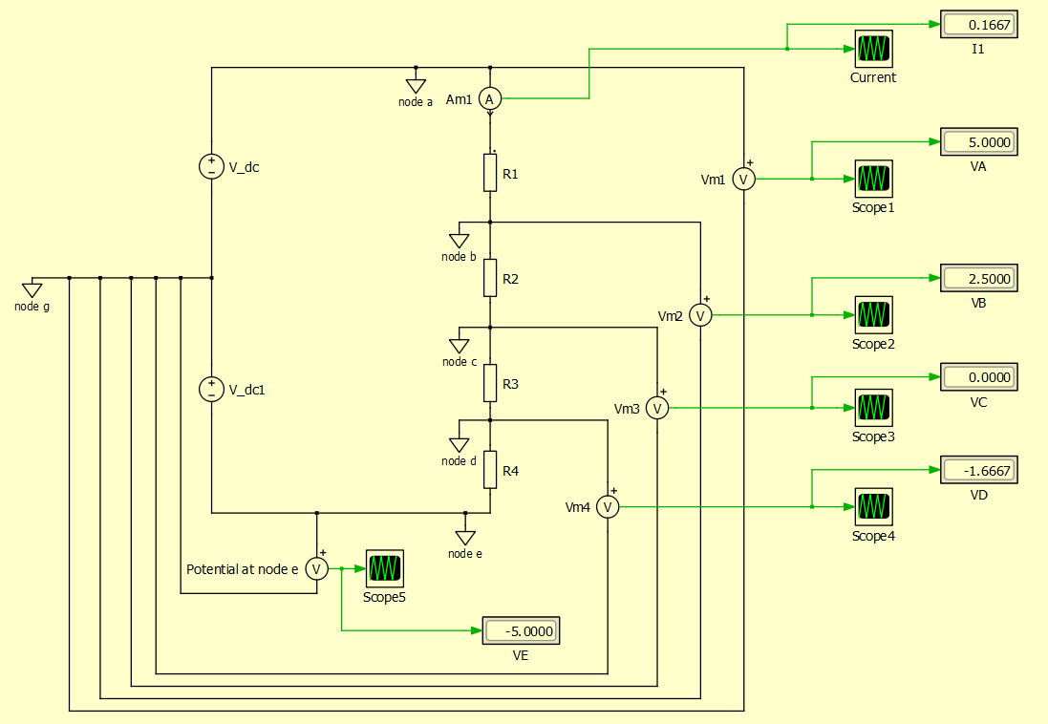

Figure 11 Measuring potential at nodes A to D

Conclusion:

**Yes**. The potentials measured from the simulation match the values calculated in Q12.

**Circuit 6: The Limits of a Potential Divider**

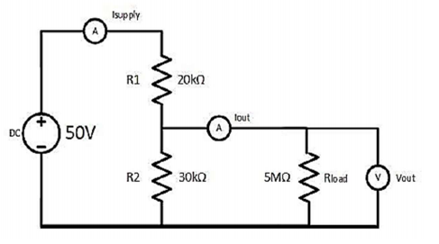

Figure 12 Circuit 6

**Question 14**

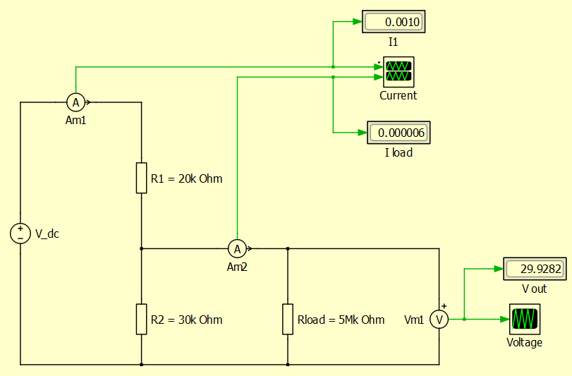

Figure 13 Circuit simulation of Circuit 6

**No**. Voltage divider rule does not apply in such connection.

To use the voltage divider rule to measure potential difference across a load, the load itself should not be connected parallel to the circuit.

**Question 15**



Figure 14.1 Rload=5MΩ

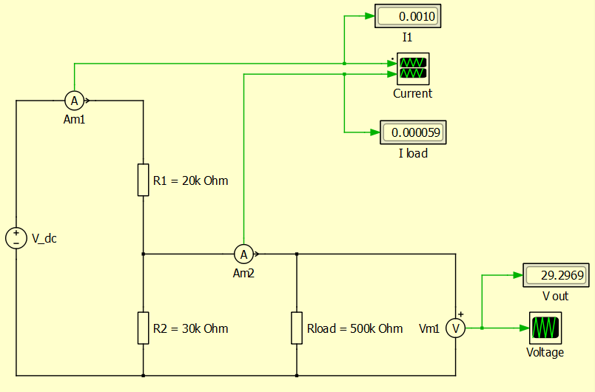

Figure 14.2 Rload=500kΩ

The potential difference across the load **() decreases**. It has decreased by 0.6313V. From 29.9282V to 29.2969V when changed from 5MΩ to 500kΩ.

**Question 16**

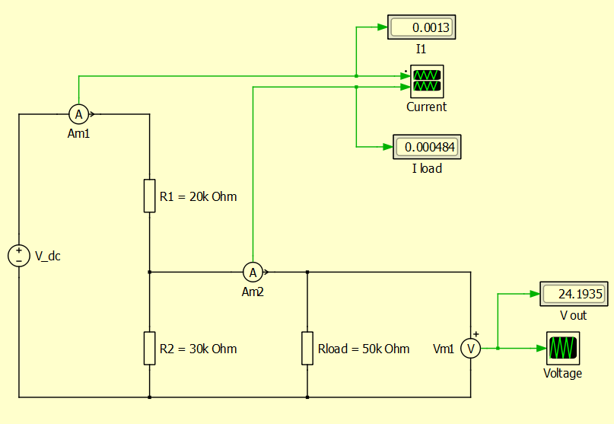

Figure 15.1 Rload=50kΩ

The potential difference across the load **() decreases**. It has decreased by 5.1034V. From 29.2969V to 24.1935V when changed from 500kΩ to 50kΩ.

Conclusion:

It was observed that  **decreases as decreases.**

**Question 17**

Potential divider rule is only applicable when the load is placed in series with the circuit, not parallel to it.

In Circuit 6, is placed in parallel with another resistor which is in series with the main circuit. That is why the potential divider rule cannot be directly applied here to calculate potential difference across the resistor.

Technically, we can still use potential divider rule to calculate which in this case, is the potential difference across the resistor. It can be calculated by first finding the total resistance of and , which are connected in parallel. However, note that this is not the best way to connect the resistor as per the connection in Figure 12, because we cannot directly use the potential divider rule to calculate the potential across the resistor.

measured in the simulation can also be calculated using the Ohm’s law or the current divider rule. Here is how to calculate simply by using Ohm’s law.

Calculating when is 50kΩ:

Total resistance of and :

Total resistance in the circuit:

Current passing through :